1- How many Namespaces exist on the system?

kubectl get namespaces

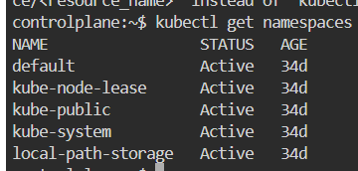

2- How many pods exist in the kube-system namespace?

kubectl get pods -n kube-system

3- Create a deployment with

Name: beta

Image: redis

Replicas: 2

Namespace: finance

Resources Requests:

CPU: .5 vcpu

Mem: 1G

Resources Limits:

CPU: 1 vcpu

Mem: 2G

4- How many Nodes exist on the system?

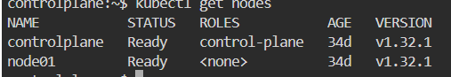

5- Do you see any taints on master?

kubectl describe node controlplane grep Taints

6- Apply a label color=blue to the master node

kubectl label nodes controlplane color=blue

7- Create a new deployment named blue with the nginx image and 3 replicas

Set Node Affinity to the deployment to place the pods on master only

NodeAffinity: requiredDuringSchedulingIgnoredDuringExecution

Key: color

values: blue

kubectl apply -f blue-deployment.yaml

kubectl describe node controlplane | grep Taints